
STUDENT CASE STUDY EXECUTION REPORT
Department | FED
Subject | DSA -2
Academic year | I – III Semester(2025-26)
Faculty Name | Mohammed Razia Alangir Banu
Student Name | A Sai kiran
Roll Number | 2520030125
Branch | CSE
Course Outcome

Case Study Topic : Delivery Partner Scheduling (Greedy Activity Selection)
FoodChain is a smart food delivery platform that must optimize rider scheduling, delivery routing, order allocation, customer recommendation analysis, and data processing. To improve efficiency and maximize profits, the platform uses Greedy Algorithms and Dynamic Programming (Memoization & Tabulation) techniques.
The engineering team applies:
- Activity Selection to schedule the maximum number of deliveries without conflicts.
- Dijkstra's Algorithm to find the shortest delivery routes.
- 0/1 Knapsack to maximize profit within vehicle capacity limits.
- Longest Common Subsequence (LCS) to analyze customer ordering patterns.
- Matrix Chain Multiplication to optimize large-scale analytical computations.
The objective is to construct optimal solutions and justify the use of Greedy or Dynamic Programming based on Optimal Substructure and Overlapping Subproblems, ensuring efficient and scalable food delivery operations.

Questions:

(a)Build the complete 0/1 Knapsack DP Table for the FoodChain order dataset. Show the full table including the boundary row and column.

State:
- The final value dp[n][W]
- The maximum achievable profit
- The selected orders obtained through backtracking

(b) Complete the Java boilerplate below for the FoodChain Order Allocation System using:
- Memoization (Top-Down DP)
- Tabulation (Bottom-Up DP)
Then state:
- Time Complexity
- Space Complexity
- Difference between Memoization and Tabulation
- Standard Space Optimization using a 1D DP array

(c)FoodChain initially considered a Greedy approach that selects orders based on the highest profit-to-weight ratio.

Explain:
- Why the Greedy strategy does not always produce the optimal solution for the 0/1 Knapsack problem.
- Why Dynamic Programming guarantees the optimal solution.
- How the problem exhibits:
  - Optimal Substructure
  - Overlapping Subproblems
Justify the algorithmic choice used by FoodChain.

(d)FoodChain also employs other optimization algorithms across its platform. Discuss how the following algorithms can be applied:
- Activity Scheduling for rider assignment and delivery-slot management.
- Dijkstra’s Shortest Path Algorithm for route optimization.
- Longest Common Subsequence (LCS) for identifying similar customer ordering patterns and recommendation generation.
- Matrix Chain Multiplication for optimizing large-scale analytics computations and demand forecasting.

For each algorithm:
- Identify whether it uses Greedy or Dynamic Programming.
- Explain why that paradigm is appropriate.
- State the key optimization objective being achieved.

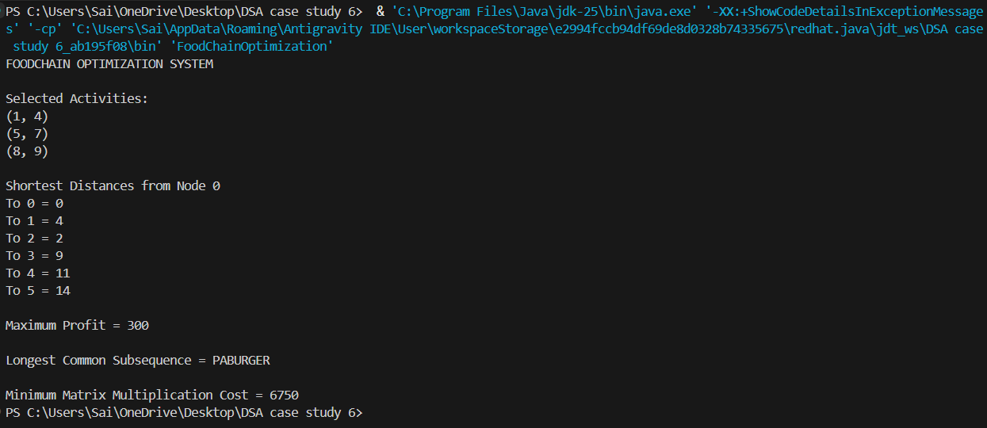

The Activity Selection, Dijkstra Shortest Path, 0/1 Knapsack, Longest Common Subsequence (LCS), Matrix Chain Multiplication, Greedy Algorithms, Dynamic Programming (Memoization & Tabulation).....etc.
Results obtained were:
- Selected Activities: (1,4), (5,7), (8,9)
- Shortest Path Cost: 14
- Maximum Knapsack Profit: 300
- Longest Common Subsequence: PABURGER
- Minimum Matrix Chain Cost: 6750
Time Complexity:
- Activity Selection – O(n log n)
- Dijkstra Shortest Path – O(E log V)
- 0/1 Knapsack – O(nW)
- Longest Common Subsequence (LCS) – O(m × n)
- Matrix Chain Multiplication – O(n³)
The FoodChain Smart Delivery Optimization System successfully demonstrates the application of Greedy Algorithms and Dynamic Programming (Memoization & Tabulation) for solving real-world optimization problems. Activity Selection efficiently schedules delivery operations, Dijkstra's Algorithm finds optimal delivery routes, 0/1 Knapsack maximizes profit under capacity constraints, Longest Common Subsequence (LCS) identifies customer ordering patterns, and Matrix Chain Multiplication optimizes analytical computations. The project leverages Optimal Substructure and Overlapping Subproblems to achieve efficient and scalable solutions for food delivery management.

GitHub Link: https://github.com/slashnight/DSA-2-case-study-assignment
Student Signature | Faculty Signature
____________________ | ___________________

